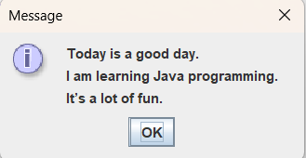
package as1;

import javax.swing.JOptionPane;

public class Message {

public static void main(String[] args) {
String msg;

msg="Today is a good day.\n";

msg=msg + "I am learning Java programming.\n";

msg=msg + "It’s a lot of fun.\n";

JOptionPane.showMessageDialog (null, msg);

}

}

